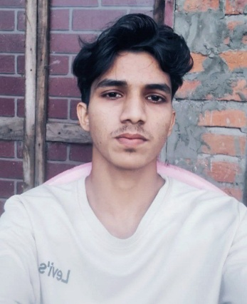

**SOE MOE NAING**

Email - soemoen900@gmail.com

Address - Kyauktaga, Bago, Myanmar (Burma)

Ph No. - 09973465722

Objectives

I am a motivated Computer Science student who has completed the first year and is waiting to begin the second year. Seeking a UX/UI internship at TAM79 to learn, contribute fresh ideas, and gain real-world experience in creating clean, engaging digital experiences.

Education

University Of Computer Studies Taungoo

B.C.Sc (Computer Science)

* First Year Completed

Experience

No Experience

Skills

* HTML+CSS, Word Press
* Basic Programming in C++, Java, Python
* Basic Database Knowledge, MySql

PROJECTs

* Ai Library - Using HTML+CSS